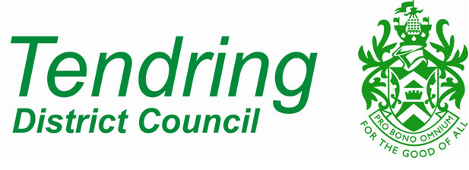

Application to Vary or Modify a S.106 Planning Obligation
Town & Country Planning Act 1990

Application to vary a S.106 agreement within 5 years of the date of the legally signed document.

Forms should be returned to:

The Planning Service, Tendring District Council, Station Road, Clacton on Sea. CO15 1SE or email via dcadmin.planning@tendringdc.gov.uk

Your Details:

Name:

Address:

Post Code:
Email Address:

Daytime Telephone Number:

Agent’s Details (where applicable)

Name:

Address:

Post Code:

Contact Name:
Email Address:

Daytime Telephone Number:

The Site:

Please provide the full Postal Address of the site to which the obligation relates.

Please detail the nature of applicant’s interest in the land.

Please provide sufficient information to enable us to identify the planning obligation to be varied i.e. planning reference and particular obligation(s) to be changed.

What reason(s) do you have for applying for a variation to the obligation(s)?

Signed Applicant:

Signed Agent:

Date:

Checklist:
- Copy of the original Agreement and any Deeds of Variation
- Copy of this form, signed and dated
- Copy of a map identifying the land to which the obligation relates
- Copy of such other information as you consider relevant to the determination of the application
- Fee (please call 01255 686190 to make payment by debit or credit card)

