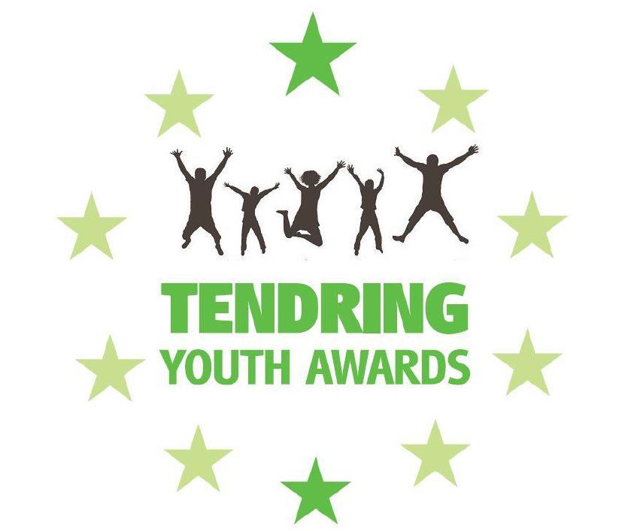

Tendring Youth Awards Nomination Form

Tendring Youth Awards are keen to promote a positive image of young people. We aim to highlight and celebrate the success of young people and their commitment to the community in and around the Tendring area.

Award categories

Volunteer (young person aged 11-21)

This award recognises the volunteering efforts of young people (aged 11-21) as an individual or as part of a group.

Arts (young person aged 11-21)

This award showcases the creative potential of a young person (aged 11-21) in any respect of the arts; including Creative (i.e. drawing or writing), Expressive (i.e. dancing or theatre) or Applied (i.e. product design or textiles).

Community Improvement (young person aged 8-21)

This award celebrates an individual or group who have significantly contributed to their community.

Young carer (young person aged 8-18)

This award recognises a young person (aged 8-18) who helps look after a relative who has a condition, such as a disability, illness, mental health condition, or a drug or alcohol problem.

Learning achievement (young person aged 11-21)

This award rewards the hard work and perseverance of a young person (aged 11-21) who has succeeded in their chosen subject or subjects showing their determination to achieve their learning goals.

Outstanding achievement (young person aged 11-21)

The Outstanding Achievement category is all about celebrating an individual or group of young people (aged 11-21) achieving in any discipline or field. Achievements must be significant and exceed the norm.

Personal Achievement (aged 8-21)

In recognition that some young (aged 8 - 21) people overcome huge difficulties to achieve success. Obstacles might include problems in their family, social, educational, health or work lives

The Environmental Initiative Award (aged 8 - 21)

Celebrating an individual or group (aged 8 - 21) who has significantly contributed to improving or caring for the environment. This award includes a Bursary, from the sponsors, Innogy, to unable to winners to continue and develop the environmental initiatives into the future

Unsung Hero (Adult)

This award is given in recognition of the efforts of an individual (adult) to support young people to achieve their full potential, through volunteering, mentoring or coaching.

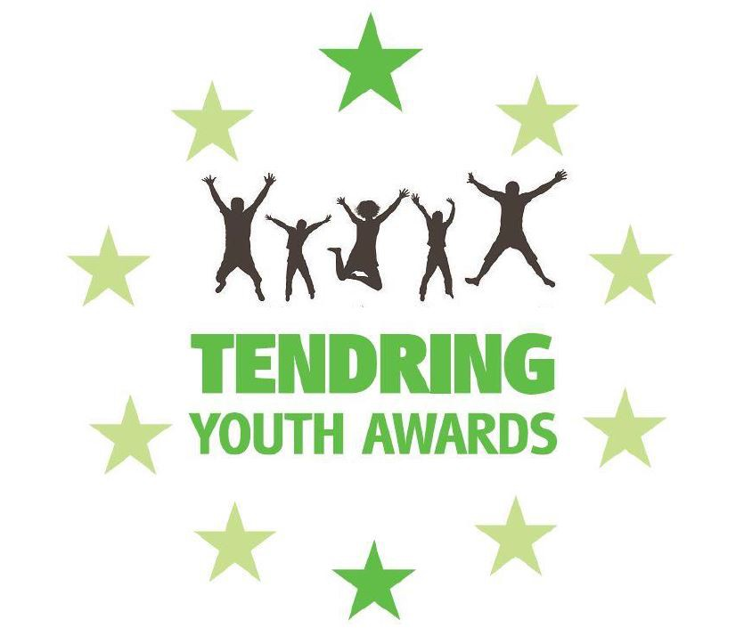

Nomination

Thank you for choosing to nominate a young person or group of young people for the Tendring Youth Awards. Please take the time to complete this form, including as much information as is possible.

Nominee - Young person / Group of young people

Please note the young person / group must live within the Tendring area.
Name of young person / group* Age of young person(s)

Select Address:

Address Line 1:* Address Line 2:
Address Line 3: Town:* County:* Postcode:

Telephone(s) Email
School / college / workplace

Category young person / group is nominated for

Please select one of the categores from the list provided above, which you wish to nominate the young person or group of young people for.
If you are unsure which category to choose simply leave all tick categories and the TYA committee will choose the most appropriate one.

Category:

Nominator - person nominating the young person or group

Name*

Telephone(s) Email* Organisation

Reason for nomination

In no more than 350 words, please state your reason for nominating this young person / group of young people (or adult if nominating for the Unsung Hero Award):

Please visit www.tendringdc.gov.uk/privacy for information on how we will process and store your nomination.

Tendring District Council is required by law to protect the public funds it administers. In order to meet this obligation this may include sharing information internally and externally, where necessary, to prevent and detect fraud, improve the way it delivers services and for the purpose of performing any of its statutory enforcement duties. This may also include sharing information with other bodies responsible for auditing and administering public funds. All personal information will be processed in accordance with current data protection legislation.
Supporting evidence

If there are any supporting items you wish to submit with your nomination (eg photographs, newspaper articles etc) please include them below. We can accept up to three scanned items or photographs of items.

Included: Included: Included:

