Flood Plan

for

Name of property

Contents

Chapter Title Page no.

- Introduction

- Background

- Warning Arrangements

- Flood Warning Codes

- Action to take on receipt of Flood Warnings

5.1 Beach Scenario

- Flood Mitigation

- Grab Bag

- What can you do? – Action Checklist

- Evacuation

- Insurance

- Pets

- When is it Safe to go back?

- How do I Recover?

- Awareness and Review

- Introduction

This section should explain the purpose of the plan.
How many people live in this residence?

- Background

This section should explain why the plan is necessary.

- Warning Arrangements

This section should state that the residents of the property are registered on the Environment Agency Floodline Warning Direct, including the phone number, and quick dial codes, obtainable from the Environment Agency

4.0 Flood Warning Codes
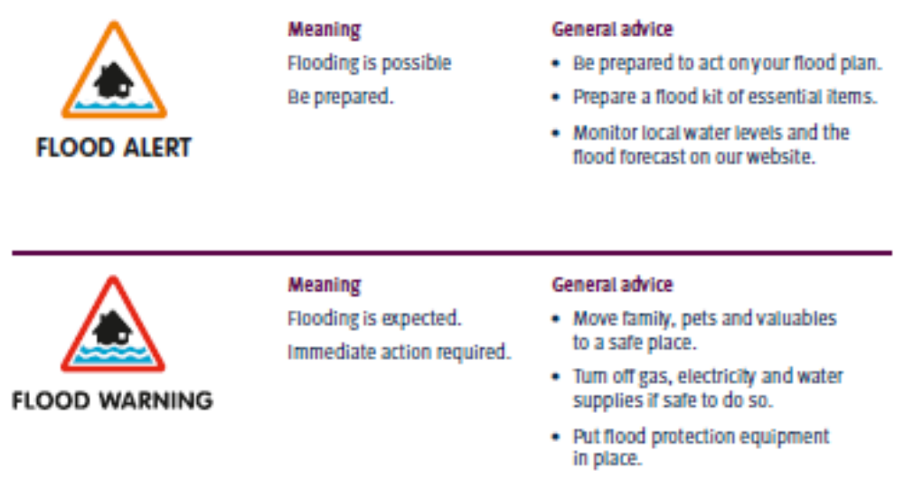
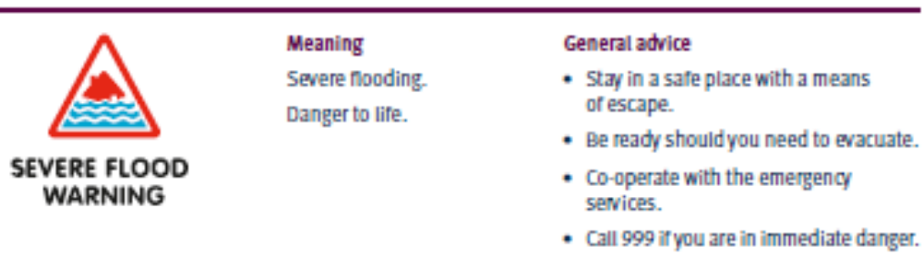
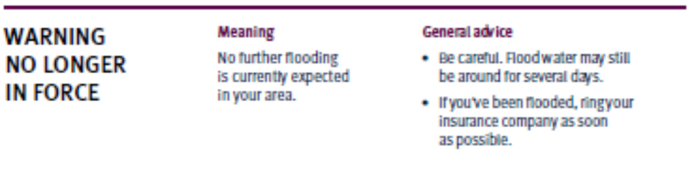

5.0 What Action will be taken on receipt of each code:
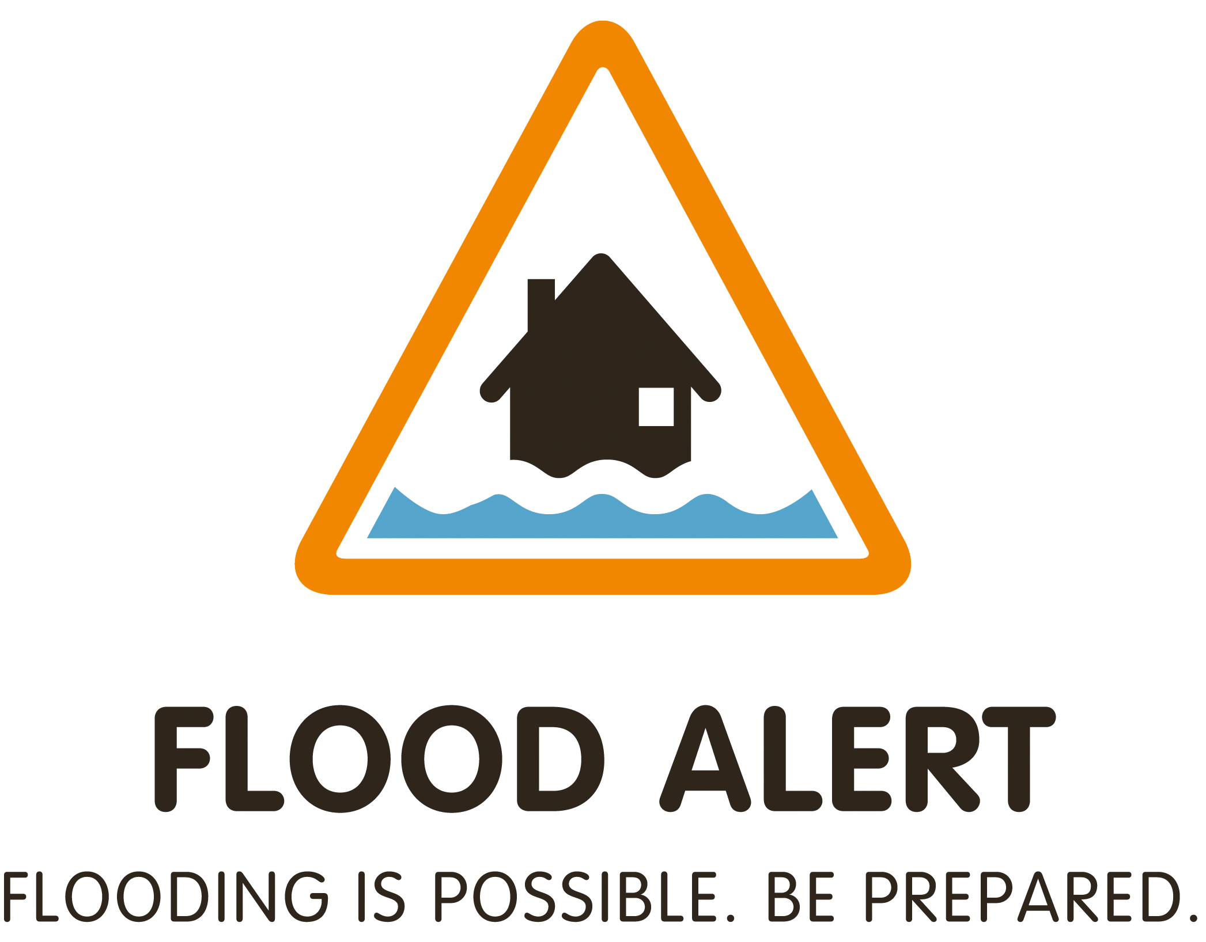 Describe the action to be taken on receipt of this
Warning.
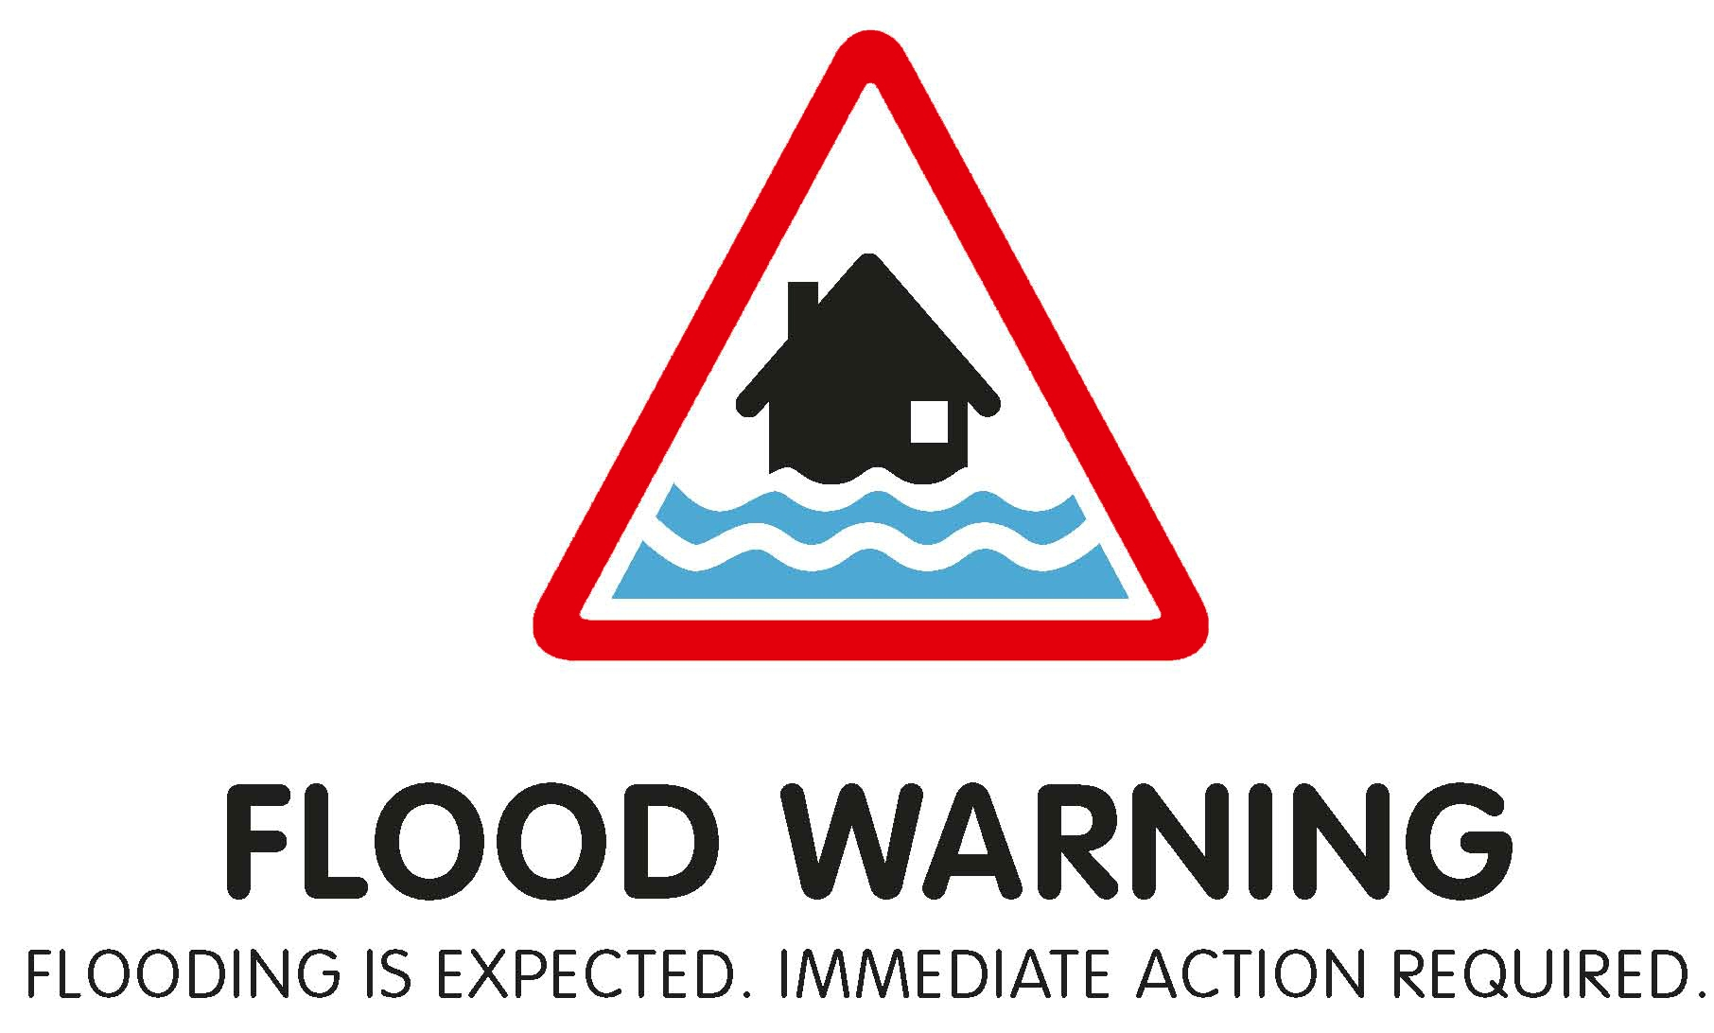 Describe the action to be taken on receipt of this
Warning.
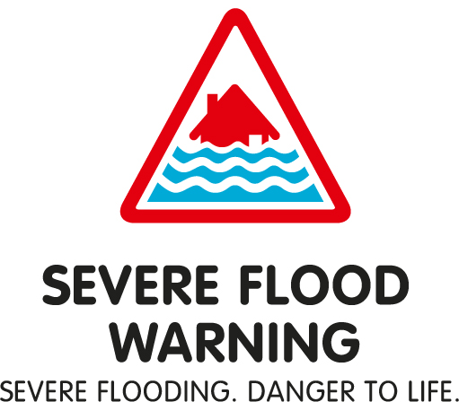 Describe the action to be taken on receipt of this
Warning.

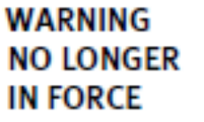 Describe the action to be taken on receipt of this
Warning.

5.1 BREACH Scenario

In the event that a sea defence fails or is BREACHED, rapid inundation may follow. The Environment Agency cannot issue warnings for a BREACH. What are the plans for this property in this situation?

6.0 Flood Mitigation

This section should identify what flood mitigation measure have been purchased to protect the property and when they will be deployed.
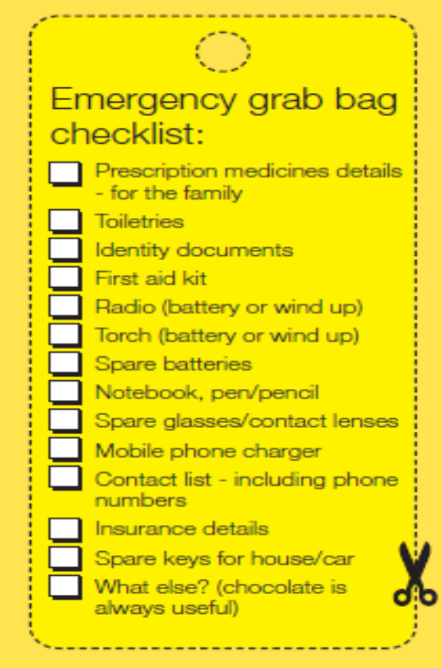
ie: airbrick covers, flood boards, sandbags

7.0 Prepare a Grab Bag

Describe the Grab Bag you have put together for all residents of the property, and where it is kept.

8.0 What can you do? Checklist √

√ Can you move valuable or irreplaceable items to a first floor, or atleast
off the ground?
√ Roll up carpets / rugs
√ Consider moving your car to higher ground, if you are not going to use
it to self evacuate.
√ Lift and hang curtains over poles
√ Place important documentation in waterproof bag
√ Any large or loose items in your garden move or weigh them down.
√ Monitor Local TV and Radio Stations for further information
√ Know where and how to turn off your: Electricity, Gas, Water

9.0 Evacuation

Describe what arrangements you have in place should you be required to evacuate from your home. Do you have family or friends outside of the flood area where you could stay? Does your home insurance cover you for alternative accommodation?

What is the safest evacuation route?

The decision to evacutate is not taken lightly and will be agreed by Essex Police and Tendring District Council. Follow the advice given by the responding organisations, it is for your safety.

If there are children and / or vulnerable persons living within the property, who has the duty of care for those individuals to ensure they are safe at all times?

Can you pre-arrange to stay with relatives or friends who live outside of the flood zone in the event of an evacuation? This will relieve the burden on the Local Authority and assist those who have no other option.

“Staying in situ”, is not an appropriate alternative. It is highly likely that in the event of a flood you will loose power, no access to sewage system (toilets and drains) as the sewage system will also be inundated, there may also be an adverse impact on your water supply. In addition there are health hazards associated to staying in properties affected or surrounded by flood water.

10.0 Insurance

Does your Home Insurance provide you with adequate cover? Will they arrange alternative accommodation for you? Have you got copies of your insurance documentation and contact details?

11.0 Don’t forget your pets

If you have pets, remember to include them in your flood evacuation plan.

Under Section 9 of the Animal Welfare Act 2006 a person commits an offence
if he does not take such steps as are reasonable in all the circumstances to
ensure that the needs of an animal for which he is responsible are met to the
extent required by good practice.

For the purposes of this Act, an animal's needs shall be taken to include—
(a)its need for a suitable environment,
(b)its need for a suitable diet,
(c)its need to be able to exhibit normal behaviour patterns,
(d)any need it has to be housed with, or apart from, other animals, and
(e)its need to be protected from pain, suffering, injury and disease.

12.0 When is it safe to go back?

The responding organisations will be providing updates on the situation and notification when it is safe to return to your home. Follow their advice.

13.0 How do I recover?

√ Do not start the clean-up until the threat of further flooding has passed;
√ Don’t throw anything away until told to do so by your insurer;
√ Check with your insurance company if it is OK to start cleaning your
property, before you start;
√ Confirm what services your insurance company will pay for;
√ Use a permanent marker to mark on the wall the height of the flood water in
each affected room;
√ All surfaces that have been covered by flood water will be contaminated,
wear waterproof, gloves, boots and a face mask;
√ Household products are sufficient to clean and disinfect your property;
√ DO NOT attempt to reconnect your utilities yourself. Liaise with your utility
Provider;
√ DO NOT use vegetables and fruit from affected vegetable beds;
√ Use mains pressure garden hose for washing down, not high pressure
hose lines;
√ As soon as possible, ask your insurance company when a loss adjuster will
visit;
√ Ask your insurance company if they will pay for repairs that will make your
property more flood resilient for the future;
√ Keep records: date, time, name of person you spoke to and what was
agreed;
√ Keep receipts;
√ Take photos and video of your damaged property;
√ Make a list of your damaged property;

14.0 Awareness and Review

Explain how are you going make sure all the residents of the property are aware of this plan?

Explain how often the plan will be reviewed / updated.

