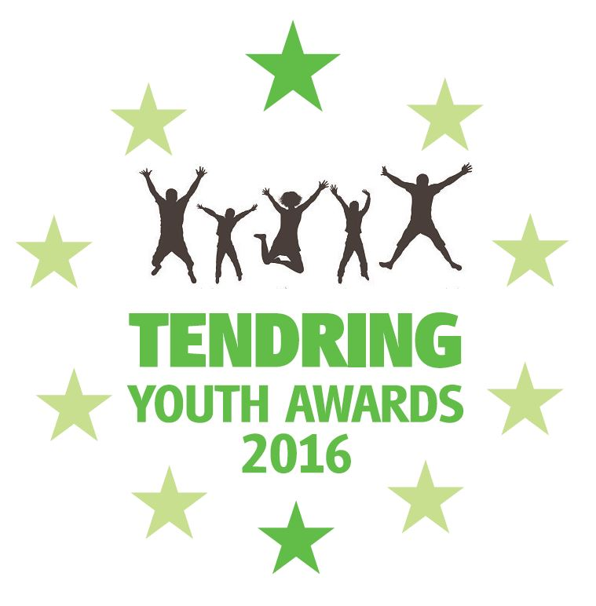

Tendring Youth Awards are keen to promote a positive image of Young People. We aim to highlight and celebrate the success of Young People and their commitment to the community in and around the Tendring area.

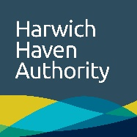
The TYA are supported by:

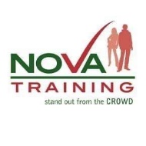
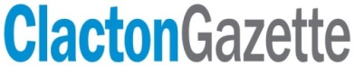

Tendring Youth Awards
2020 Nomination Form

Please send completed nomination forms to:
Tendring Youth Awards (Nominations),

Town Hall, Station Road, Clacton on Sea, Essex, CO15 1SE

All nominations MUST be received by Friday 24th April 2020
Tendring Youth Awards @tendring_youth_awards
Tendringyouthawards@gmail.com
Award categories
Volunteer (Young Person aged 11-21)
Sponsored by: tbc
This award recognises the volunteering efforts of young people (aged 11-21) as an individual or as part of a group.
Arts (Young Person aged 11-21)
Sponsored by: The Princes Theatre
This award showcases the creative potential of a young person or group (aged 11-21) in any respect of the arts; including Creative (i.e. drawing or writing), Expressive (i.e. dancing or theatre) or Applied (i.e. product design or textiles).
Community Improvement (Young Person aged 8-21)
Sponsored by: Harwich Haven Authority
This award celebrates an individual or group who have significantly contributed to their community, and includes a bursary from the sponsor to enable the winners to continue to develop their initiative.
Young Carer (Young Person aged 8-18)
Sponsored by: Tendring Careline
This award recognises a young person (aged 8-18) who helps look after a relative or friend who has a condition, such as a disability, illness, mental health condition, or a drug or alcohol problem.
Learning Achievement (Young Person aged 11-21)
Sponsored by: Tendring District Council
This award rewards the hard work and perseverance of a young person (aged 11-21) who has succeeded in their chosen subject or subjects showing their determination to achieve their learning goals.
Outstanding Achievement (Young Person aged 11-21)
Sponsored by: Essex County Council
The Outstanding Achievement category is all about celebrating an individual or group of young people (aged 11-21) achieving in any discipline or field. Achievements must be significant and exceed the norm.
Personal Achievement (Young Person aged 8-21)
Sponsored by: Nova Training
This award is given in recognition that some young people (aged 8-21) overcome huge difficulties to achieve success. Obstacles might include problems in their family, social, educational, health or work lives.
Environmental Initiative (Young Person aged 8-21)
Sponsored by: Galloper Wind Farm
Celebrating those who have significantly contributed to improving or caring for the environment. This award includes a bursary from the sponsors to enable the winners to continue and develop their environmental initiatives into the future.
Unsung Hero (Adult)
Sponsored by: Harwich Haven Authority
This award is given in recognition of the efforts of an individual (adult) to support young people to achieve their full potential, through volunteering, mentoring or coaching.

Reason for Nomination
Thank you for choosing to nominate a young person or group of young people for the 2020 Tendring Youth Awards. Please take the time to complete this form, including as much information as is possible. Details of how to submit this nomination can be found on the first page.
Nominee – Young Person/Group of Young People
Name of Young Person/Group
Age
Address  (Please note the young person/group must reside within the Tendring area) | Postcode:
Town
Postcode
Telephone/s
Email
School/College/Workplace
Category Young Person/Group is being nominated for
Please select one of the categories from the list provided below, which you wish to nominate the Young Person or Group of Young People for.

Volunteer |  | ❍
Arts |  | ❍
Community Improvement |  | ❍
Young Carer |  | ❍
Learning Achievement |  | ❍
Outstanding Achievement |  | ❍
Personal Journey  Environmental Initiative |  | ❍  
Unsung Hero (Adult) |  | ❍
See page 2 for information about each category. If you are unsure which category to choose simply leave all tick boxes blank and the TYA Committee will choose the most appropriate one.

Nominator – Person nominating the Young Person or Group
Name
Address | Postcode:
Telephone/s
Email
Organisation
Reason for Nomination
In no more than 350 words, please state your reason for nominating this Young Person/Group of Young People (or Adult if nominating for the Unsung Hero Award):
*Please continue on a separate sheet, if needed.
Supporting Evidence
If there are any supporting items you wish to enclose with you nomination (i.e. Photographs, newspaper articles etc.) Please list them below.

Supporting item 1:
Supporting item 2:
Supporting item 3:
Please DO NOT send originals as these cannot be returned
Confidentiality & Storage of Personal Data:
All nominations forms are securely stored as we are aware that some information in them is personal and sensitive nature. Forms will be confidentially disposed of at the earliest convenience after the awards ceremony has taken place. See website for privacy notice.

