The Priory, St. Osyth
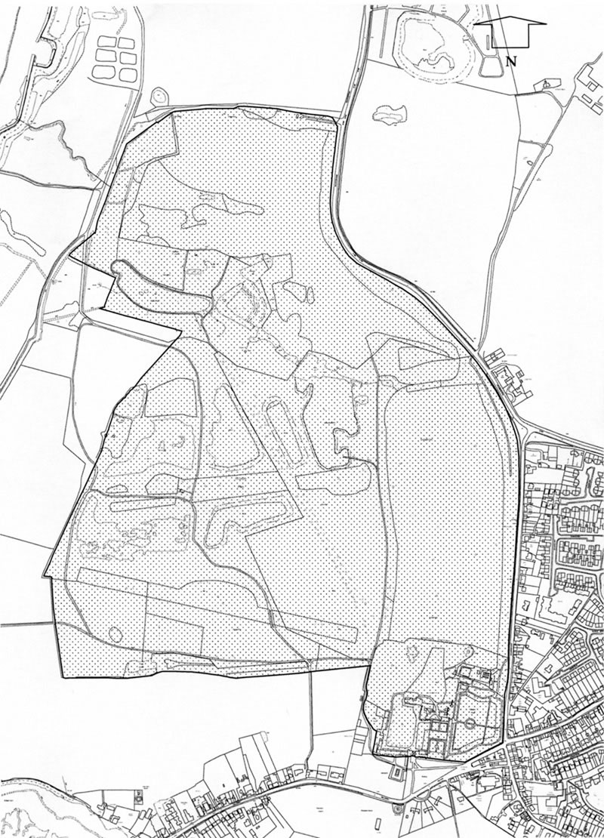

Historic Development
The house at St Osyth was originally a medieval priory of Augustinian Canons and the present house incorporates fabric from the C12 onwards. A triple gatehouse was added in the C15 and the Bishop’s Lodging by Abbot John Vintomer in 1527. Following its dissolution in 1539 St Osyth’s Priory was initially granted to Thomas Cromwell but after his execution in 1547 was given to Princess Mary, with reversion to Thomas Darcy. By 1553 Darcy had gained possession of St Osyth’s and his son, the second Lord Darcy, entertained Queen Elizabeth there in 1561 and 1570. Darcy built an addition to Abbot Vintomer’s range, and south of this made two walled gardens. The first mention of the Great and Little Parks at St Osyth’s date from this time (Debois 2000). The third Lord Darcy was made Earl Rivers by Charles I and his heiress was made Countess Rivers, the earldom continuing through her until the fourth Earl died in 1712 without legitimate male heir. The Essex property, with St Osyth’s as the main seat, was left to his natural daughter Bessy Savage, while the extensive remainder of the estate was inherited by the heirs of the Earl’s legitimate daughter. Bessy married Frederick Zuylestein de Nassau, third Earl of Rochford in 1714 but as her contested inheritance was only confirmed on her in 1721, any major building works were probably not undertaken until after that date. Their son, William Henry, a considerable amateur plantsman, inherited as fourth Earl in 1738. He is credited with the introduction of the Lombardy poplar to Britain before 1758, following a period in Turin as British envoy, and also corresponded about trees with the Earl of Coventry at Croome Court, Worcs (qv).

An estate map of 1762 by Eyre shows the grounds of St Osyth’s, including an elaborate water garden in Nun’s Wood, and a hermitage and gardens around the house. On William Henry’s death in 1781 the title was inherited by his nephew, but the St Osyth’s estate passed to an illegitimate son, Frederick Nassau, who married Catherine Rose, Baronne de Brackel in 1797. An estate survey of 1814 shows the grounds slightly modernised, either by Frederick or by William Henry. Entries in the estate accounts books (ERO) for 1774-5 suggest that the formal water garden was reworked at this date. Frederick died in 1845 and was succeeded by his son William Frederick who committed suicide in 1857, leaving the estate in trust for his two daughters.

They sold the property in 1858, which by 1863 had come into the ownership of Sir John W Johnson who undertook large-scale restoration, extensive remodelling of the gardens, and planting in the park. In 1909 he was succeeded by his adopted daughter Mabel Watts, who in 1913 married Arthur Cowley. During the First World War the house was requisitioned by the Forces during the Second World War and in 1948 was converted into a convalescent home. The Priory estate was purchased by Somerset de Chair in 1954 although the house continued to be used as a convalescent home until 1980. On the death of Somerset de Chair in 1995 the estate was put up for sale and was purchased by the Sargeant family in 1999. The site remains (2000) in single private ownership.

Description
St Osyth’s Priory is located in the village of St Osyth, close to the Essex coast and on the east side of the St Osyth and Flag Creek estuary. This is a popular holiday area, where the level ground gives long views over the flat landscape and the estuary waters. The c 76ha site is bounded by a farm track and agricultural land to the north, by the main road from Colchester to the east, and by the road known as The Bury and the village green to the south. The western boundary looks out across the flood plains of the estuary.

The Priory and its associated building are located in the south-east corner of the site, approached through an imposing late C15 gatehouse of knapped flint (listed grade I) situated on The Bury. This leads directly into The Green, a garden court on the south front of the Priory. From the northern boundary an early C18 drive, altered to its present alignment in the mid C18 and now (2000) a track, enters the park close to the Colchester Road (late C18 lodges demolished 1960s). It follows a curving line south through the park to arrive at the stable buildings on the west side of The Green. A late C20 drive enters the site through the buildings of Priory Farm and joins the north drive to the west of the Green. A further C18 entrance from the western boundary no longer survives.

St Osyth’s Priory (listed grade I; whole Priory site is a Scheduled Ancient Monument) is an imposing mansion of red brick, ashlar, black diapering and a septaria chequer-work, under a red-tiled roof, built in a T-plan. The entrance front faces south onto The Green, while the north front faces the garden lawn and parkland beyond. The complex structure incorporates Bishop Vintomer’s c 1527 buildings, a mid C16 wing and the eastern Clock Tower added by Lord Darcy, mid C18 west and south wings by Lord Rochford, and a mid C19 east wing. All ranges were subject to later C19/C20 alterations. A red-brick wall (listed grade II*), now a garden wall but originally part of Lord Darcy’s C16 building, is attached to the south-east tip of the Priory and runs east to join the mid C16 Darcy Tower (listed grade I). The octagonal tower is built of ashlar and septaria, in three stages with raised turrets at three angles. On the north side of the Tower is the Chapel (listed grade I) incorporating medieval work. Beyond the Chapel, c 75m to the north are the ruins of the east range (listed grade I) of the Lord Darcy’s C16 house.

The garden at St Osyth’s lies to the south, east, and north of the Priory. The Green between the Gatehouse and the Priory is enclosed by a mid C16 garden wall (listed grade II) to the east, running south from, and attached to, the Darcy wall, and by a range of buildings to the west which include a C16 barn (listed grade I), a C16 brewhouse (listed grade II), and a medieval barn, chicken house, and cottage (listed grade II*). The courtyard is laid to lawn set with walnut trees at the south end, and is surrounded by a gravel drive. Stone steps at the Priory end of the lawn lead onto a lower flat area, in the centre of which stood a sundial in the late C19, the centrepiece of a small flower garden which no longer survives.

To the east of The Green, reached through a gate in the C16 garden wall, is a Topiary Lawn filled with clipped yew and edged with brick paths, divided by a brick pergola running south from the Darcy wall to a sunken bowling green. The Topiary Lawn and pergola, which date from the late C19/early C20, are enclosed to the east by a further mid C16 garden wall (listed grade II). At the southern end of the bowling green, steps lead up to a gateway through a yew hedge dividing the C16 walled garden in half, into a Rose Garden laid out in a complex parterre of box-edged borders and gravel paths. The Rose Garden is also a late C19 feature, which has been completely replanted in the late C20. The south boundary wall of this compartment forms the southern boundary wall of the site. Beyond the walled garden to the north-east is a woodland walk which wraps around the eastern end of the Priory buildings. This is situated on the site of the C18 Wilderness shown schematically on both the 1762 and 1814 surveys which was substantially reworked in the mid C19 by Sir John Johnson in the form which survives today (2000). In the south-east corner of the gardens, bordered to the north by the Wilderness, is an open lawn with late C20 herbaceous borders aligned on Darcy’s Tower and leading east to a small hedged area known as the Monks Cemetery.

To the north of the Priory is a large open lawn set with mature cedar of Lebanon, and bounded to the north by ha-ha. A small informal lily pond c 100m north of the house is surrounded by mixed shrub planting. By 1874 Sir John Johnson had reworked this area, which has been the C18 pleasure ground, incorporating some of the park to the north into the north lawn to make a new boundary which would accommodate the creation of the lily pond, all that remains of his Japanese Garden.

The large park at St Osyth’s lies to the north of the Priory buildings. It is retained under grass and is crossed by avenues and thin belts of mixed species tress, with several oak pollards of great antiquity. The open park immediately to the north of the Priory has been devoid of tress since the storms of the late 1980s and was labelled the ‘Mowing Ground’ on the 1814 plan, prior to which it contained a mount (estate map, 1762). By contrast, in the south-west section, known as Priory Park, many mature individuals survive. The central section of the park, known as Deer House Park, is covered with old and modern gravel extraction pits, those from the C19 having been recolonised by vegetation, while some of the C20 pits are now (2000) filled with water. In the centre of the western boundary is a hummock on which is planted a copse, known as Grotto Grove, which contains the remains of a flint shell house (listed grade II), close to the foundations of a second building known as The Kitchen. These two buildings are first shown on the 1762 plan, labelled ‘Hermitage’, and are part of the work undertaken by the fourth Earl of Rochford.
To the north of the gravel extraction area is the dense Nun’s Wood containing a string of ponds which represent the remains of an elaborate water garden. Nun’s Wood was probably the site of a nunnery and the ponds part of a medieval fishing system (Debois 2000). During the mid C18 however the fourth Earl of Rochford began to convert the ponds into a water garden, the idea for which may have been started by his father, the third Earl. Estate accounts (ERO) refer to work in Nun’s Wood between 1774 and 1780 and as well as the waterworks, the Wood was extensively replanted with shrubberies, parts of which survive. Further planting was undertaken by Frederick Nassau in the early C19 but the layout remained largely unaltered until the early C20, since when it has become invaded with self-sown trees and scrub. Beyond Nun’s Wood is a further area of open parkland, known as Lodge Piece, with few surviving individual trees but an extensive perimeter plantation called The Belt which runs all along the eastern boundary. This was described as a nursery on the 1762 plan, which also shows a drive running through it. During the late C20 the plantation has been partly replanted and deepened.
The park is crossed by two large avenues of trees and a thin mixed belt in the south-west corner of the park known as the West Strip, planted on a bank which represents the position of the C18 West Avenue. The strip radiates from the same point c 200m north-west of the Priory as the Nun’s Wood Avenue, which is aligned on the centre of Nun’s Wood. It is crossed by the Chestnut Avenue which runs east/west through the park from the north drive to the western boundary just south of Grotto Grove and is shown in this position on the 1762 plan. It is possibly a survivor from an earlier formal layout (Debois 2000).

The walled kitchen garden lies c 150m to the north-east of the Priory, reached via the woodland walks through the Wilderness. It is divided into two by a central walk and contains a perimeter gravel path edged by box borders. The ground is partly laid to grass and partly cultivated for vegetables. Beyond the northern boundary wall is a late C20 wild garden. The kitchen garden was built in this position by the fourth Earl of Rochford in the mid C18.

