Generic Emergency Plan

for

Name of Site

This template has been produced by Tendring District Council.
It is not an exhaustive template.
There may be additional sections that are specific to your site.

Written by
XXXXXXXXXXXXX

Distribuition List:

Who receives a copy of this plan – internal and external

Organisation | Address | Department
Tendring District Council | Barnes House, 92 Pier Avenue, Clacton on Sea CO15 1NJ | Emergency Planning

Equality and Diversity Statement:

Include your organisations procedure for E&D

Ownership and Amendments

This document is owned by *************

Amendments for this document should be notified to **********************

Record of Amendments / Review:

Date | Amendment / Review | Name of Author

Contents

Chapter Title Page no.

SECTION 1: Generic Planning
- Introduction 04
1.1 Background 04
1.2 The Site 04
1.3 Local Risk Assessment 04
1.4 Local Skills and Resources 05
1.5 Key Locations 05
1.6 Emergency Contact List and Cascade 05
1.7 List of Site Organisations 07
1.8 Activation and Triggers 07
1.9 First Steps in an Emergency 07
1.10 Draft Site Emergency Group First Meeting Agenda 08
1.11 Evacuation 08
1.12 Actions Agreed with Local Authority in the
Event of an Evacuation 09
1.13 Alternative Arrangements for Staying in Contact
if usual Communications Have Been Disrupted 09
1.14 Self Help 09
1.15 Insurance 10
1.16 Pets 10

SECTION 2: Fire Plan (or other site plans)
Insert copy of your Fire Plan here

SECTION 3: FLOODING
03 Introduction 10
3.1 Warning Arrangements 11
3.2 What Action will be Taken on receipt of each code 12
3.3 Flood Mitigation 12
3.4 What can you do? Checklist 12

SECTION 4: RECOVERY
04 When is it Safe to go back? 13
4.1 How do we recover? 13

SECTION 5: AWARENESS AND REVIEW
5.0 Awareness 13
5.1 Staff Training 13
5.2 Review 13

SECTION 6: Emergency Contact Numbers
6.0 Emergency Contact Numbers 14

SECTION 7: Flood Warning Information Sign
7.0 Flood Warning Information Sign 15
- Introduction

This section should explain the purpose of the plan.

How many people occupy this site: permanent / holiday
live in this residence?

1.1 Background

This section should explain why the plan is necessary.

  - The Site

This section should give a detailed outline of:
- the site;
- the number of static caravans;
- the number of touring pitches;
- the number of camping pitches;
- the number of gas canisters per pitch;
- a layout of of the site;
- the amenities on site;
- number of occupants on site throughout the year staff / customers (sping / summer / autmn / winter)
- how numbers of persons on site / occupied pitches are recorded / updated

  - Local Risk Assessment

Enter the potential risks you think may impact your site, an example has been entered for you:

Risk Risk | Imapct on Site | What can Site Manager & Staff do to prepare? | What can Site occupants do to prepare?
Strong winds | Blown debris  Falling branches | Ensure site is kept tidy;  Ensure condition of trees are monitored;  Monitor weather forecasts;  Make site occupants aware of situation | Ensure the area around their pitch is clear of loose articles;  Report anything untoward to the site staff as soon ass possible;  Follow instruction given by site management and staff
  - Local Skills and Resources

Detail skills and resources available on site and that can be called upon in an emergency or the potential for an emergency, an example has been entered for you:

Skills and Resources | Who? | Activation or Contact details | Location
Trained First Aider | Bob Smith | Call out by PA / 07790 123456 | Reception

  - Key Locations

Notable location on site, such as useful halls, catering, resturant facilities and offsite, such as alternative accommodation arrangements in the event of evacuation of site, (an example has been entered for you). List where are key stop-cocks, valves, switches etc located for utilities ie water, gas, electric? What hazardous materials are on site, where and how are they stored?

Building | Location | Potential usage in an emergency | Activation or Contact details
Main leisure complex | On site | Muster station for site occupants and staff | By Duty Site manager, PA system and door knocking
Hazardous Material | Location | Storage | Emergency action required
Gas Cylinders | 2 per pitch | xxx | xxx
Chemicals
Oil tanks

  - Emergency Contact List and Casacde
This provides the identity and contact details of the sites emergency response command and control structure. This is useful both for staff, occupants, but also responding organisations such as Fire and Rescue Service and Tendring District Council. Tendring District Council will use these nominated points of contact to call in the event of an emergency or developing situation.
Picture | NAME:
Picture | TITLE: Site Emergency Co-ordinator
Picture | 24hr telephone contact:
Picture | Email:
Picture | Address
Picture | NAME:
Picture | TITLE: Site Emergency Co-ordinator – 1st Alternate
Picture | 24hr telephone contact:
Picture | Email:
Picture | Address
Picture | NAME:
Picture | TITLE: Site Emergency Co-ordinator
Picture | 24hr telephone contact:
Picture | Email:
Picture | Address

Emergency Cascade Tree:
The Emergency Cascade Tree indicates who is responsible for alerting whom. Roles could be allocated to each team member.
Emergency
Co-ordinator
Em. Co-ordinator
1st Alternate
Em. Co-ordinator
2nd Alternate

  - List of Site Organisations:

Use this space to record information relating to groups associated with the site: residents associations, national company organisation and groups, sector specific groups, an example has been entered for you:

Sunny Retreat Residents Association | Chair: Mr Bob Smith,  Address:  Contact details:
Britsh Holiday and Home parks Association | http://www.bhhpa.org.uk/members.asp

1.8 Activation and Triggers

Use this space to record how your plan will be activated. You should include details of how the plan will be activated as a result of a call from the emregncy services or local authority and also how your site will decide to activate the plan yourselves.

  - First Steps in an Emergency

Create a checklist to help you ensure as many aspects as possible have been considered, with the highest poriority first (some emergencies require slightly different order of response but this gives an indication of things to do), some examples have been entered for you:

 | Task | Allocated to:  (team member) | Tick when Completed
1 | If life believed to be in danger call 999 – unless alerted already
2 | Ensure you are in no immediate danger
3 | Contact Emergency Co-ordinater or alternate
4 | Provide information to staff
5 | Provide information to site occupants
6
7
8
9
10

1.10 Draft Site Emergency Group First Meeting Agenda

Date: | Time:
Location:
Attendees:

1.What is the current situation?
Fire
Flooding
Outbreak of illness
Lost child
Weather forecast

Location of Emergency:

Are there vulnerable people involed?
Elderly
Families with children
Disabled
Other special needs
Non –English speaking people

What resources do we need?
Food
Off-road vehicles
Blankets
Shelter
Alternative accommodation

2.Establishing Contact with the Emergency Services

3.Establish Contact with Tendring District Council

4.What actions can safely be taken?
Static / touring pitches – machinery – vehicles (site and public) – equipment moveable items – furniture – food –
Buisness critical – computers – data – staff information – databases – paper records (not an exhaustive list)

5. Who is going to take the lead for the agreed actions?

6.Any other issues?

1.11 Evacuation

Describe what arrangements you have in place should you be required to evacuate your site. How are evacuation routes identified? Where are and how are muster points idenified? Role call / identifiation of missing persons? How is the evacuation message cascaded across the site staff and customers?

The reason for evacuation maybe be taken by the site operator, in reponse to an incident on site or under direction from Essex Police, as in the case of coastal flooding. In all circulstances the decision to evacutate is not taken lightly and should be agreed either by the site operators, or will be agreed be agreed by Essex Police and Tendring District Council. Follow the advice given by the responding organisations, it is for your safety.

Can your residents pre-arrange to stay with relatives or friends who live outside of the flood zone, in the event of an evacuation? This will relieve the burden on the Local Authority and enable those who have no other option.
Does their home insurance cover you for alternative accommodation?

1.12 Actions Agreed with Local Authority in the event of an Evacuation

What does your Fire Plan say about evacuation? What alternative accommodation arrangements do you already have? Are your more permanent residents required to have another home (primary residence?)
- Map of evacuation route
- Distance to a point of safety
- Arrangements at point of safety

1.13 Alternative Arrangements for Staying in Contact if Usual
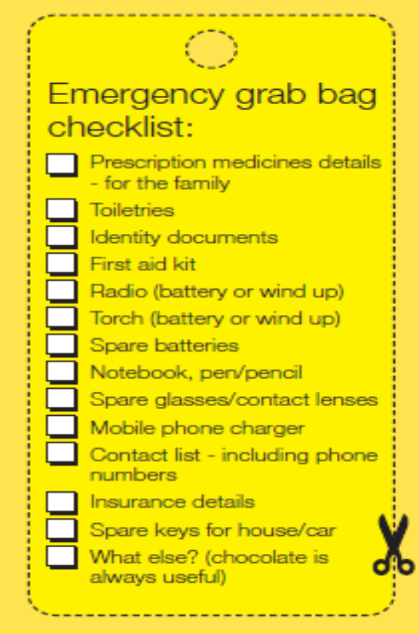
Communications Have Been Disrupted

Use this space to record details of alternative communications within your local area, should usual method of communications be disrupted, This could include owner / locations of long distance walkie-talkies. It could identify if you are lcoated in a poor mobile phone signal area for all or specific networks.

1.14 Self Help

What self help arrangement advice do you share with the occupants on site?
- Make a grab bag;
- Make sure your residents know what to do on receipt of each level of warning;
- Know where and how to turn off utilities such as water, electric, gas;

1.15 Insurance

Does your business insurance provide you with adequate cover? Will they arrange alternative accommodation for you / your customers? Have you got copies of your insurance documentation and contact details?

Do your customers have appropriate insurance cover? Are they covered for alternative accomodation?Do they have copies of their insurance documentation and contact details?

1.16 Pets

Are pets allowed on site? If so, remind residents to included their pets in their
emergency planning arrangements.

SECTION 2: FIRE PLAN (or other appropriate site plans)

Insert the details from your Fire Plan or other plans that you have for the site here, some information in it will be relevant for your Generic Emergency Plan, there is no point re-inventing the wheel.

SECTION 3: FLOODING

If your site is in a known EA Flood Warning Area, complete the following section; If your site experiences surface water flooding complete the following section;

- Introduction:

Use this space to explain the flood risk to this site.
Use this table to identify the Environment Agency Flood Warning Areas your site is located within and record the data, including the Quickdial code.

EA Flood Warning Area | (delete areas that are not appropriate for your location)  Area Description | 0845 9881188 select option 1 enter quick dial code from list below
054FWCDV4B5 | Tidal Stour Estuary | 111020
051FWCDV4B6 | Waterside properties at Mistley and Brantham | 111015
051FWCDV4B7 | Manningtree Town | 111010
054FWCDV4B8 | River Stour upstream of Cattawade Barrage | 111025
051FWCDV4B9 | Parkeston Quay and the Ramsey River | 111030
051FWCDV4B10 | Harwich Town, Dovercourt and Bathside Bay | 111035
051FWCDV4B11 | Hamford Water | 111040
051FWCDV4B12a | Walton on the Naze | 111045
051FWCDV4B12b | Holland Marshes | 111045
051FWCDV4C1a | The Coast from Clacton to Lee Wick | 111101
051FWCDV4C1b | Tidal River Colne at Point Clear and Saint Osyth Creek | 111101
051FWCDV4C1c | Tidal River Colne from Brightlingsea to the Colne Barrier | 111101
3.1 Warning Arrangements

This section should state that the operators and residents of the site are registered on the Environment Agency Floodline Warning Direct, including the phone number, and quick dial codes, obtainable from the Environment Agency. Explain how the operator will promote and engage with residents to ensure those on site are registered.

Flood Warning Codes
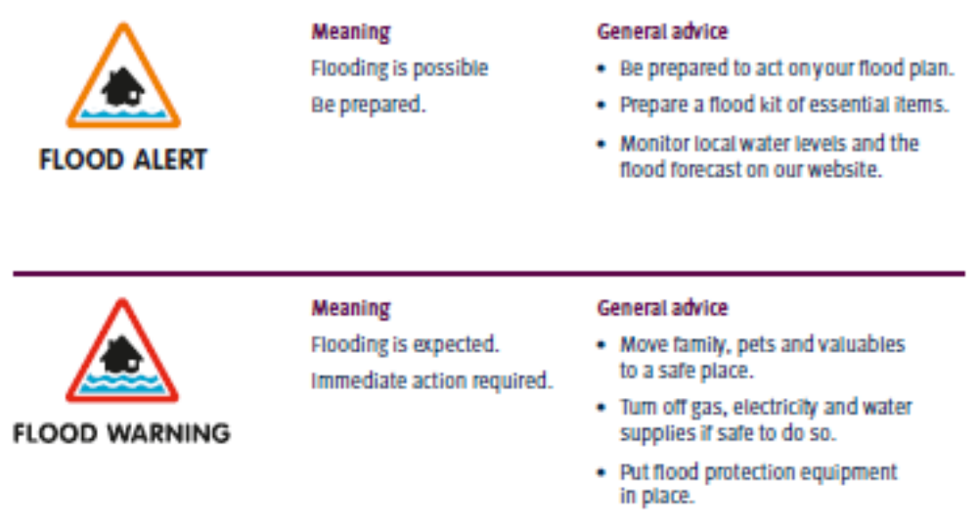
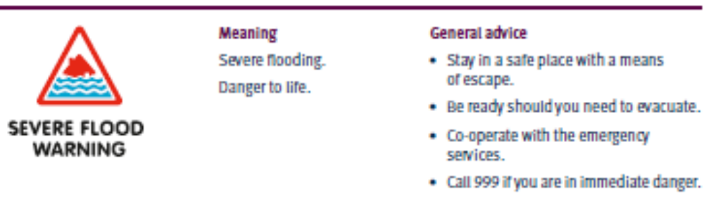
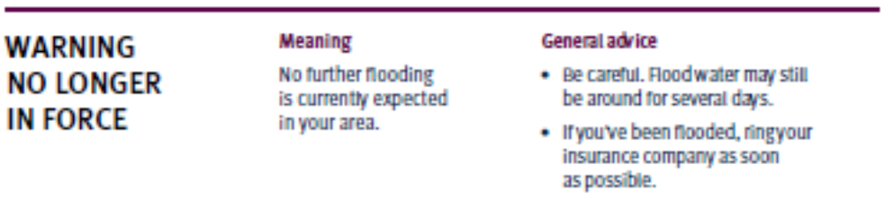

3.2 What Action will be taken on receipt of each code:

 Describe the action to be taken on receipt of this
Warning.
 Describe the action to be taken on receipt of this
Warning.
 Describe the action to be taken on receipt of this
Warning.

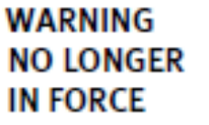 Describe the action to be taken on receipt of this
Warning.

3.3 Flood Mitigation

This section should identify what flood mitigation measures have been purchased to protect the site and when the will be deployed.
ie: airbrick covers, flood boards, sandbags

3.4 What can you do? Checklist √

√ Can you move valuable or irriplaceable items to a first floor, or atleast
off the ground?
√ Roll up carpets / rugs
√ Consider moving your car to higher ground, if you are not going to use
it to self evacuate.
√ Lift and hang cutains over poles
√ Place important documentation in waterproof bag
√ Any large or loose items in your garden move or weigh them down.
√ Monitor Local TV and Radio Stations for further information
√ Know where and how to turn off your: Electricity, Gas, Water

SECTION 4: RECOVERY

4.0 When is it safe to go back?

The reposnding organisations will be providing updates on the situation and notification when it is safe to return to your site. Follow their advice.

4.1 How do we recover?

√ Do not start the clean-up until the threat of further impact, such as flooding,
has passed;
√ Don’t throw anything away until told to do so by your insurer;
√ BEFORE you start, check with your insurance company if it is OK to start
cleaning;
√ Confirm what services your insurance company will pay for;
√ Use a perminant marker to mark on the wall the height of the flood water in
each affected room / location;
√ All surfaces that have been covered by flood water will be contaminated,
wear waterproof, gloves, boots and a face mask;
√ Household products are sufficient to clean and disinfect your property;
√ DO NOT attempt to reconnect your utilities yourself. Liaise with your utility
provider;
√ DO NOT use vegetables and fruit from affected vegetable beds;
√ Use mains pressure garden hose for washing down, not high pressure
hose lines;
√ As soon as possible, ask your insurance company when a loss adjuster will
visit ;
√ Ask your insurance company if they will pay for repairs that will make your
property more flood resilient for the future;
√ Keep records: date, time, name of person you spoke to and what was
agreed;
√ Keep receipts;
√ Take photos and video of your damaged property;
√ Make a list of your damaged property;

SECTION 5: Awareness, Training and Review

5.0 Awareness

Explain how you are going make sure all the residents of the property are aware of this plan?

5.1 Staff Training

Explain how your staff will be trained in these proceedures and maintain their skill level.

5.2 Review

Explain how often the plan will be tested / reviewed / updated.
SECTION 6: Emergency Contact List (examples added)

Police | If Life in danger | 999
 | Routine
Fire | If life in danger | 999
 | Routine
Ambulance | If life in danger | 999
 | Routine
HM Coastguard | Emergency | 999
 | Routine | 01255 675518 | 24/7
NHS
Tendring District Council | Emergency Contact | 01255 222022 | 24/7
 | Routine EP | 01255 686319/971 | eplanning@tendringdc.gov.uk  www.tendringdc.gov.uk  twitter: @tendringdc
Environment Agency | Emergency | 0845 9881188 | www.environment-agency.gov.uk
Met Office |  |  | www.metoffice.gov.uk
Insurance Company
Electricity Provider
Water Provider
Sewage provider
Gas Provider

Teleophone Provider
Your Head Office

SECTION 7: Flood Warning Information Sign



